A Bus Company owns a number of buses. Each bus is allocated to a particular route, although some routes may have several buses. Each route passes through a number of towns. One or more drivers are allocated to each stage of a route, which corresponds to a journey through some or all of the towns on a route. Some of the towns have a garage where buses are kept and each of the buses are identified by the registration number and can carry different numbers of passengers, since the vehicles vary in size and can be single or double-decked. Each route is identified by a route number and information is available on the average number of passengers carried per day for each route. Drivers have an employee number, name, address, and sometimes a telephone number.

Instructions:

* Design conceptual model(s) for the above description.
* Conceptual model--> identify major **entities**, **associations between them** (relationships), **Identifier** (primary key)
* Use MySQL workbench and attach a screenshot to this document.
* List out your assumptions if any.

**Screenshot of conceptual model:**

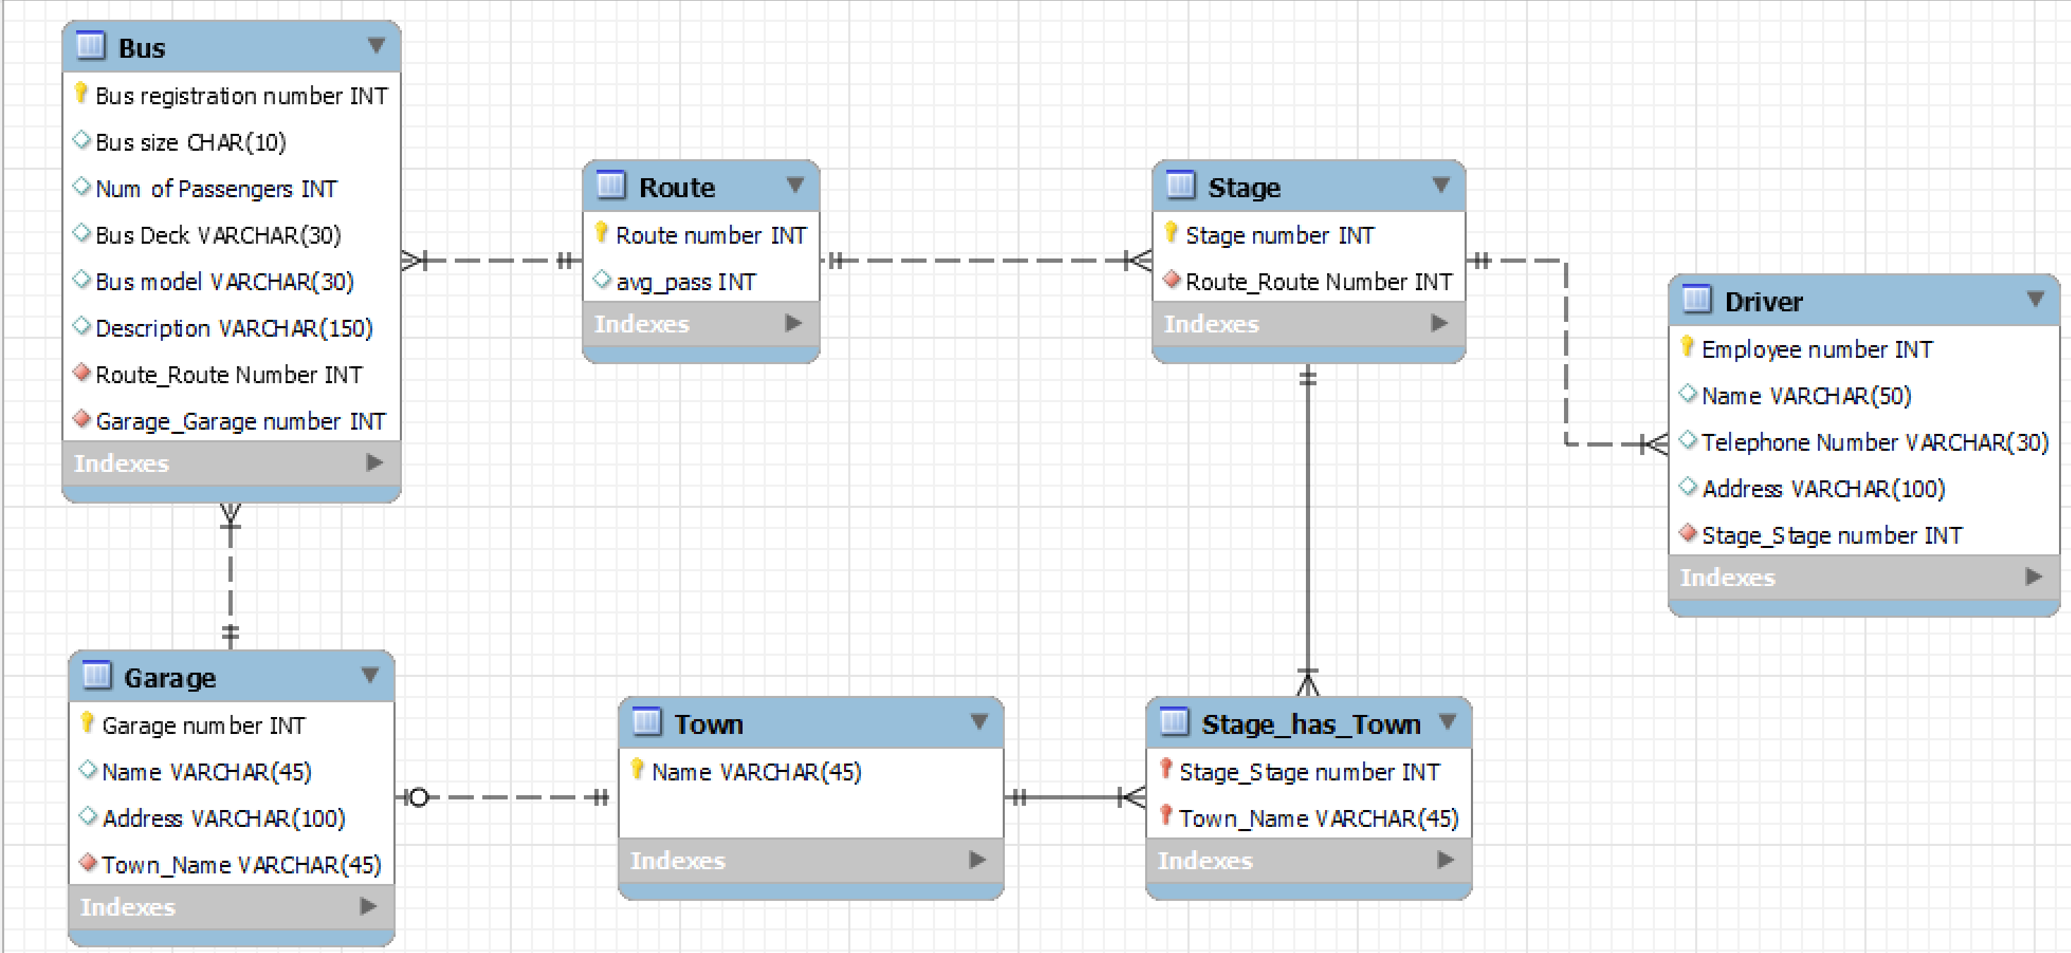

**Business Logic/Assumptions:**

* There are 6 main entities namely Bus, Garage, Route, Stage, Town and Driver and 1 associative entity ‘Stage has Town’
* Every Garage will have a Garage number indicated
* A town may or may not have a Garage
* If a town has a Garage, it will have maximum of only 1 Garage
* A bus is allocated to a route and a route may have several buses.
* A route comprises of one or more stages
* One or more drivers are allocated to each stage.
* A stage passes through some or all of the towns on a route.
* A route passes through some or all of the towns
* A garage keeps buses and each bus has one garage